From: https://davidstockmanscontracorner.com/caution-the-feds-pop-up-repo-windows-reflect-very-tiny-brains-at-work/

Caution! The Fed's Pop-Up Repo Windows Reflect Very Tiny Brains At Work
By David Stockman. Posted On Thursday, September 26th, 2019
It doesn't get any stupider than this. Just as fast as the Fed pumps up the size of its freshly minted repo facilities, demand for speculative borrowing leaps another leg higher.
After the Fed upped the overnight facility to $100 billion yesterday when it received $92 billion of bids under the original $75 billion overnight facility and announced three 14-day term facilities of $30 billion/$60 billion/$60 billion, the Wall Street gamblers have apparently said we'll see your $250 billion and raise, again.
Thus, at this morning's $60 billion term repo offer, the Fed received $72.5 billion of bids. And that wasn't reflective of a mere overnight pinch: This was 14-day money!
Needless to say, the talking heads are gumming up a storm about why this is suddenly happening---quarter-end and all.
But there's no mystery whatsoever. Two numbers from this morning's Fed announcement tell you everything you need to know. We are referring to 1.86% and 1.89%, which were the "stop-out" yields on the $35.75 billion of bids accepted for UST-backed loans and $24.25 billion accepted for MBS-collateralized loans, respectively.
That is to say, the Fed has commanded that interest rates on all forms of money market loans including secured repo shall stay strictly within its current 1.75%-2.00% range. And that's as in come hell, high water or, heavens forfend, the law of supply and demand itself.
There are truly very tiny brains at work in the Eccles Building. If this is just a quarter-end matter per the vast majority of Wall Street commentary---so what, then, if repo rates temporarily spill over the top of the Fed's absurdly low Fed funds range?
Is the "greatest economy ever" actually so fragile that Wall Street dealers and hedge funds can't afford to pay 5% or even 10% for a couple of days or weeks on their massive, money-making balance sheets where their carry cost is still negative after inflation? And has been for an entire decade!
And if the pressures roiling the money markets are of a more permanent nature---so what, again!
Always and everywhere, the ultimate cure for excess credit demand is higher rates, not more fiat money supply. And history shows that purging and clearing speculative markets does not kill capitalism; it rejuvenates it.
So this bears repeating: These $250 billion of instantly stood up repo lines have absolutely nothing to do with
- the main street economy or
- the Fed's so-called dual mandate.
That's because the 1.85%/1.89% yields accepted by the Fed this morning to fund Wall Street balance sheets are in a totally different universe than main street. Currently
- auto loans are 4-7%,
- personal loans range up to 17% and,
- according to Wallet Hub, rates on credit cards currently stand at 14% to 22% depending upon on credit scores
No, these "pop-up" repo windows have been hurriedly erected at the behest of the Wall Street whiners, who think the Fed owes them access to virtually unlimited ultra-cheap funding for their carry trade speculations.
Nor can you exaggerate the level of entitlement and greed involved. Way back in what is now ancient history---April 2008--- the Fed lowered the funds rate to 2.0% in a desperate efforts to bolster a main street economy which was already in recession, even though the 12 FOMC geniuses managing the economy had no clue at the time.
As we pointed out a few days ago, the 12-month inflation rate was then 2.95%. So the cost of carry trade funding on Wall Street was a full point below the inflation rate and the gap only got wider from there.
By January 2012, for instance, the Fed funds rate was still down on the floorboard at a mere 10 basis points, while the trailing 12-month inflation rate posted at 2.60%, meaning that the real (inflation-adjusted) cost of money was -2.50%.
And, yes, that is a negative sign in front of the after-inflation cost of goods sold (COGS) for carry traders (i.e. their COGS is the short-term cost of the borrowed money with which they purchase their earning assets).
So the Wall Street traders literally thought they had died and gone to heaven. Indeed, only in December 2018 did the Fed get the effective funds rate a hair above the inflation rate.
That tiny rebirth of sanity, of course, was instantly stillborn when Pusillanimous Powell pivoted within days owing to the loud barking from the Oval Office and the plunging stock averages of Christmas Eve massacre.
So here we are 137 months from the original April 2008 break out of negative cost money and we are back under water with the Fed's money market target rate of 1.85% well below the 2.19% trailing rate of inflation.
The latter inflation figure is from our preferred very stable and reasonably accurate 16% trimmed mean CPI. But if you don't like that one, take this morning's freshly revised Q2 data for the PCE deflator and the PCE deflator less food and energy, which the Fed heads like better because they generally measure inflation at somewhat lower rates.
But not now. The annualized rate of the PCE deflator for Q2 2019 was 2.36%, and when you lop off food and energy it was 1.90%.
Either way you cut it, the Fed's mid-point funds target is below inflation. Yet, apparently, and so that no one is confused, it swooped in today with the aforementioned $60 billion of 14-day repo at 1.86%/1.89%. That is, clearing any and all money market decks at yields which are still negative in inflation-adjusted terms.
The way to view this is that the area in the chart below between the purple line (inflation) and the dark green line (Fed funds effective rate) is one great bubble bath of free lunch profits for the Wall Street dealers and gamblers.
So the question recurs: Why do the very tiny brain denizens of the Eccles Building insist on pleasuring Wall Street speculators in the prodigious profits pool depicted below?
Alas, it's because these arrogant apparatchiks presume that they can defeat the law of supply and demand and that left to its own devices, capitalism has a death wish.
That is, free markets always get the interest rate wrong and it's almost always way too high, thereby discouraging an invisible economic ether called aggregate demand.
By contrast, the 12 very stable geniuses who sit on the FOMC are purportedly endowed with the extraordinary wisdom needed to get it right. They enable the benighted souls of main street---workers, management, entrepreneurs and investors alike---to be guided to ever greater prosperity by the visible hand of central banking experts rather than stumble about chasing the unseen hand of mere commercial enterprise.
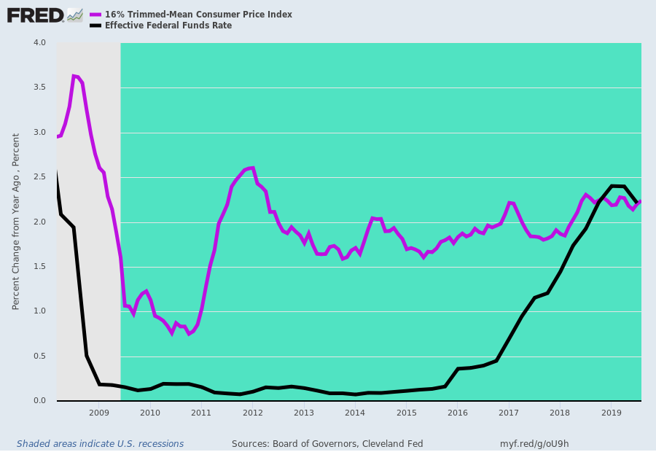
Of course, the fly in the ointment ain't that hard to see if you are not drinking the Cool Aid of monetary central planning.
That is, if you subsidize something you get more and more of it. And for more than a decade the Fed has been massively subsidizing carry trade speculation---especially up in the higher tree-tops of the casino where the big boys speculate via the embedded carry trades of the options and structured finance.
Stated differently, there is only one place 137 months of negative real money rates can lead. Namely, to the mother of all stock market bubbles (and subsequently to the greatest bust ever).
In that regard, on the very heels of WeWork's spectacular bust of the past several weeks, wherein its market cap deflated from $47 billion to $10 billion before its sponsors cried Uncle and slithered off the IPO stage completely, today we got Peloton taking a powder.
The estimable Gary Kaltbaum just posted a note explaining why it opened nearly 9% below its already reduced IPO rigging last night, thereby making the second worst IPO opening in Wall Street history:
Peloton (PTON) came public today at $29. As we write this, it trades at $26.50. Nice job Wall Street.
To be clear, we have no idea what the stock does in the short run and for that matter, we will be watching how it trades in the long run. We will also be watching their business, their sales, their earnings (losses) and their ability to grow all. But we just wanted to point out a few things for you to mull over.
They charge $4,250 for a treadmill. The biggest selling treadmill on Amazon sells for less than $900. We found plenty of treadmills on-line for under $200...of course, not as cool and with less bells and whistles but let's not forget, for many, price matters. They charge $2,245 for their stationary bicycles. Guess what price we found on-line for stationary bicycles? Yes...under $200. Again, not as cool and not with the bells and whistles but for many, price counts.
They lost $245 million last year on $900 million and change sales. But who's counting?
Last we looked, there is a ton of competition. Every health club, companies like Echelon and last we looked, it is cheap to buy a regular bicycle and last we looked, it is free to walk.
We have an idea what the H&R Block-types would be saying a lot of their revenue growth. Much of their growth is coming from zero-interest loans which carry risk of losses if the loans go bad. We are not saying the loans will go bad. We are saying it is these types of loans that will go bad first when someone is in a pinch. On that note, what purchases do you think slow down if the economy slows down?
And on that accounting note, according to its IPO documents, Peloton books these zero-interest loan sales as full purchases from the moment the customer gets on the equipment. That is not unusual. Many companies do book the revenue before they have been paid. But most of them will record an accounts receivable to identify cash that they are still waiting to collect. While its sales rose by $480 million in its last fiscal year, its accounts receivable rose by just $9 million. Not sure Mr. Block, Mr. Ernst and Mr. Young would be too happy with this.
We can go into other boring things like Peloton's overly aggressive churn rate predictions but to us, the bottom line, it would be nice to see one of these companies that are coming public sell something for $1 and actually make $1.10. Just ain't happening right now.
Still, the insidious regime of monetary repression embodied in the Fed's latest folly----virtual pop-up repo windows---has infected far more than just the late-cycle IPO precincts.
This morning the venerable McDonald's was on a tear after it announced a new product called P.L.Ts. We rather thought that a "plant, lettuce and tomato" sandwich amounted to a bit of redundancy, but it was just the thing to give its red hot supplier, Beyond Meat Inc., a much needed 11% boost to its meatless, profitless market cap of $9.3 billion.
After all, that's down 35% from its post-IPO peak of $14.1 billion on July 26 . We are not sure, of course, as to exactly what type of "price discovery" caused its valuation to drop from 85X its LTM sales of $165 million just 60 days ago to a mere 56X after today's booster shot, but at least you can say that it was surely directionally correct.
But what isn't even directionally correct is the absurd current valuation of it latest Fake Meat customer. That is, McDonald's is currently trading at 28X it's $5.9 billion of LTM net income, and that makes no sense whatsoever.
That's because for the last six years, Mickey D's earnings have been dead in the water. To wit, since December 2013, its worldwide revenues have dropped from $28.1 billion to $20.1 billion, while its net income crawled imperceptively forward from $5.59 billion in December 2013 to $5.89 billion during the June 2019 LTM period.
Yet a mere 5% gain in income over nearly six years didn't stop its market cap from soaring on the back of the Fed third and greatest bubble of all time. As shown below, McDonald's market cap rose from $95 billion to $162 billion during the same period, meaning that 90% of the gain was from PE expansion.
That's right. There is no earthly reason why the PE of a tired purveyor of preformed cholesterol paddies should experience a PE expansion from an already frisky 17X to today's absurd 28X....except, except for the speculative mania that the Fed and other central banks have unleashed on Wall Street.

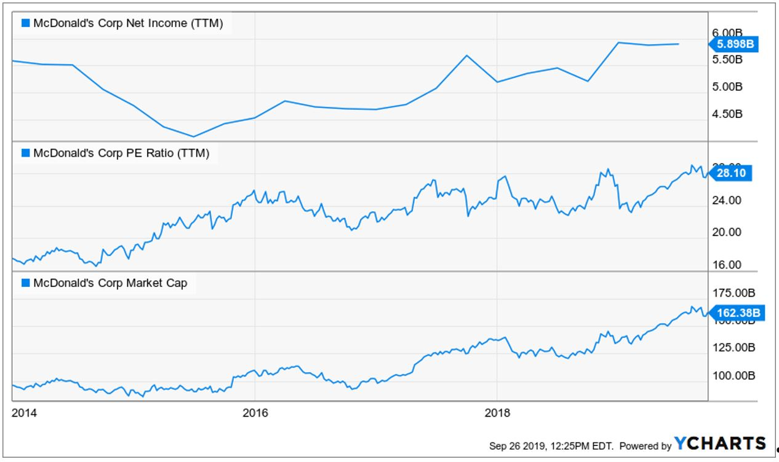
And for want of doubt, note that a certain long time ago offspring (spin-off) of McDonald's, which has also suffered an extended bout of stagnation, is valued even more absurdly. We are referring, of course, to Chipotle---which is currently valued at 92X its LTM net income.
Then again, its net income of $327 million for the LTM period ending in December 2013 has become, well, just $249 million for the LTM period ending in June 2019.
So how did its market cap manage to soar from $16 billion to $23 billion during the same period.
There is obviously no mystery about that, either. To wit, it was due to PE expansion from an already lunatic 50X back in 2013 to the hideous 92X at which it closed today.
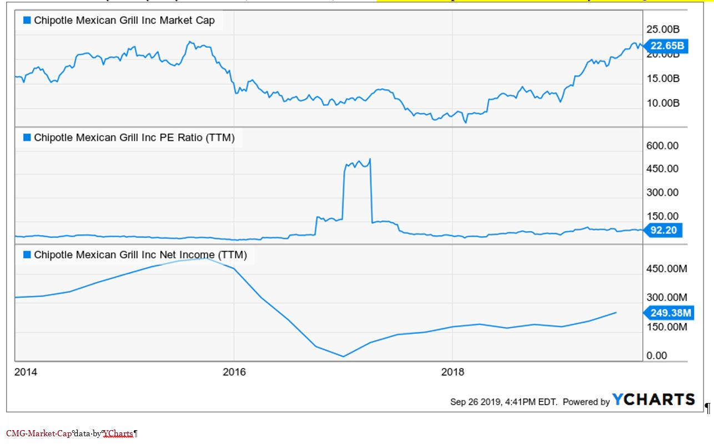
Do the very tiny brains at the Eccles Building understand what they are really doing?
We judge, they do not. Today two retired lifers from the Fed system penned an op ed suggesting that the current pop-up repo facilities are just a start. They actually want to peg every single rate in the entire money market and explicitly target the multi-trillion repo sector by means of a "standing repo facility".
You can't make this up. Joseph Gagnon and Brian Sack make so bold as to suggest that the Fed bring its printing press out of the basement, and set it up dead center on Wall Street.
Presumably, the gamblers can then frequent this monetary drive-by window on their way to Mickey D's or Chipotle, as the case may be.
They urged the Fed to adopt a standing fixed-rate repo facility under which banks and other selected financial institutions could borrow from the central bank, arguing that would provide a “guard rail” against unexpected market developments.
Gagnon and Sack also called on the central bank to abandon its federal funds rate target and adopt the repo rate -- as measured by the secured overnight financing rate –- as its objective instead.
“The Fed should be explicit about its desire to control the repo rate,” they said.
Sack was formerly an executive vice president at the Federal Reserve Bank of New York, where he served as the head of the Markets Group and the manager of the System Open Market Account for the Fed from 2009 to 2012.

